**ELaNa XX**

**Vanderbilt University / AMSAT-NA**



**RadFXSat-2** **Vibration Test Report**

## Satellite Team Change Log

|  |  |  |  |
| --- | --- | --- | --- |
| **Revision** | **Date** | **Author** | **Change Log** |
| 0 | 7/4/2018 | Robert Davis | Initial write. |

## Satellite Team Responsible Engineers

|  |  |
| --- | --- |
| **Author** | **Contact** |
| Robert Davis | KF4KSS@amsat.org |
| Gerald Buxton | foxse@n0jy.org |

**Purpose**

The purpose of this document is to outline the results for the random vibration of RadFXSat-2. It is a 1U CubeSat. It will launch on ELaNa XX, in a Xtenti FRA-R3S. The test was performed in an equivalent-interface Test-POD from Cal Poly. Vibration is performed to prove the CubeSat can survive launch and ascent according to L1-VCLS-ICD-20 (ICD ¶3.6.5.1). Vibration was performed at NTS-Boxborough, MA on June 19, 2018. The GEVS Protoflight level was tested, which is the 14.12 Grms Qualification level (+3dB above 10.0 Grms Acceptance) but held for a duration of 2 minutes/axis.

**Requirements Verified**

* **L1-VCLS-ICD-20** – The UCPs shall perform a random vibration test at the levels shown in Figure 3-17 to prove that the UCP can survive launch and ascent. (GEVS Acceptance level)

**Test Levels**

Per the CubeSat ICD requirements 6.4.3 and 6.4.4, RadFXSat-2 was subjected to random vibration test to ensure structural stability of the design and workmanship of assembly.

The GEVS Qualification and Acceptance random vibration profiles are shown below in Figure 1.

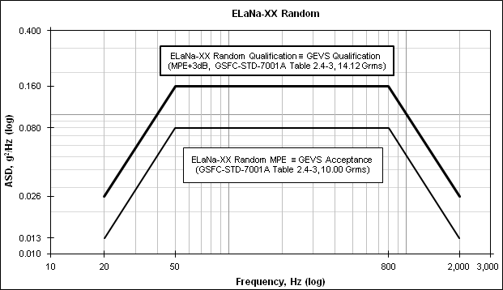

Figure 1 ELaNa XX (GEVS) Random Vibration Profiles

The GEVS Protoflight qualification level was tested, which is the 14.12 Grms Qualification level (+3dB above 10.0 Grms Acceptance) but held for a duration of 2 minutes/axis.

RadFXSat-2 was subjected to a sine sweep before and after each axis of random vibration test to identify possible structural changes.

The low level signature sine survey profile is shown below in Table 1.

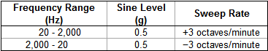

Table 1 Sine Survey Profile

1. **Results**

RadFXSat-2 random vibration was completed on June 19, 2018, at NTS Boxborough.

* + **Pre-vibration Operational Tests**

Prior to integration into the TestPOD, RadFxSat-2 was operationally tested.

RadFXSat passed the Short Functional Test (umbilical power; battery charge; umbilical & RF commands; RF transmitted telemetry including antennas are stowed; RF transmitted automated voice announcement; RF transmitted voice repeater operation).

RadFXSat passed the Aliveness Test (pull RBF pin then hear buzzer; re-install RBF pin before antennas deploy).

* + **Test Article Photo**

Pre-vibe wear of TestPOD was noted only on the contact areas of the door plate. No wear was visible in the TestPOD at the rails or pusher plate.

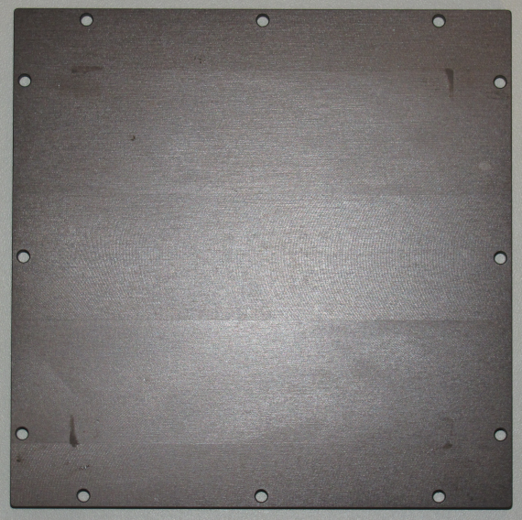

Figure 2 Pre-vibe wear of TestPOD door

RadFxSat-2 was placed into the TestPOD so the coordinate systems would align, as shown in Figure 3. The RadFxSat-2 coordinate system is difficult to read in this photo, but toward the bottom in red Sharpie is the +X axis and green Sharpie is the +Y axis.

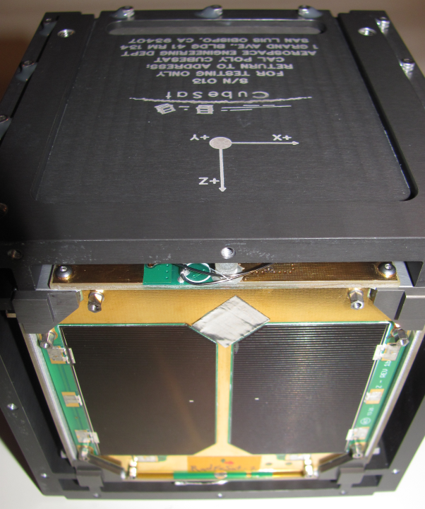

Figure 3 RadFxSat-2 & TestPOD coordinate systems align

The CubeSat’s exposure to oily shop air was limited by sealing the TestPOD by covering holes while in an office environment.

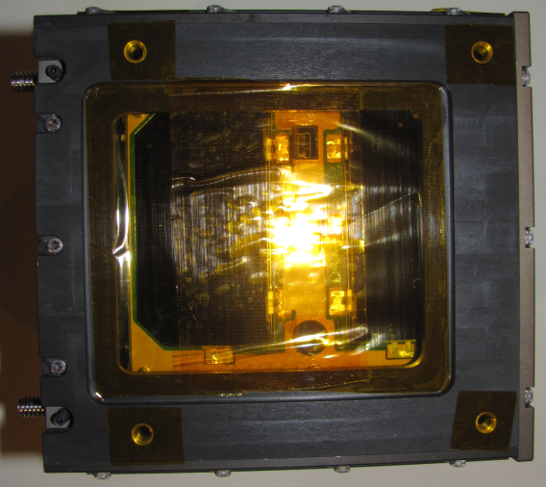  
Figure 4 TestPOD Access Panels and unused holes were covered

* + **Z-axis Data**

Z-axis was performed on the slip table, and using Procedure Rev 3.

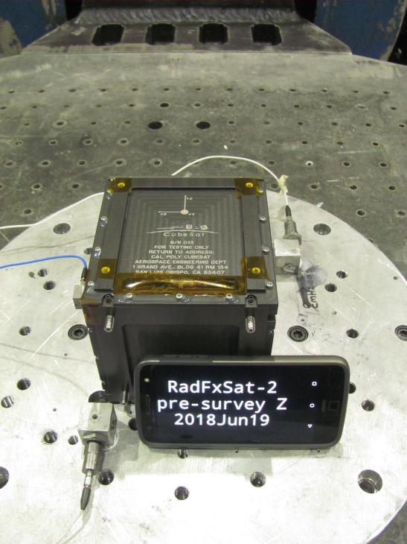

Figure 5 Z-axis setup

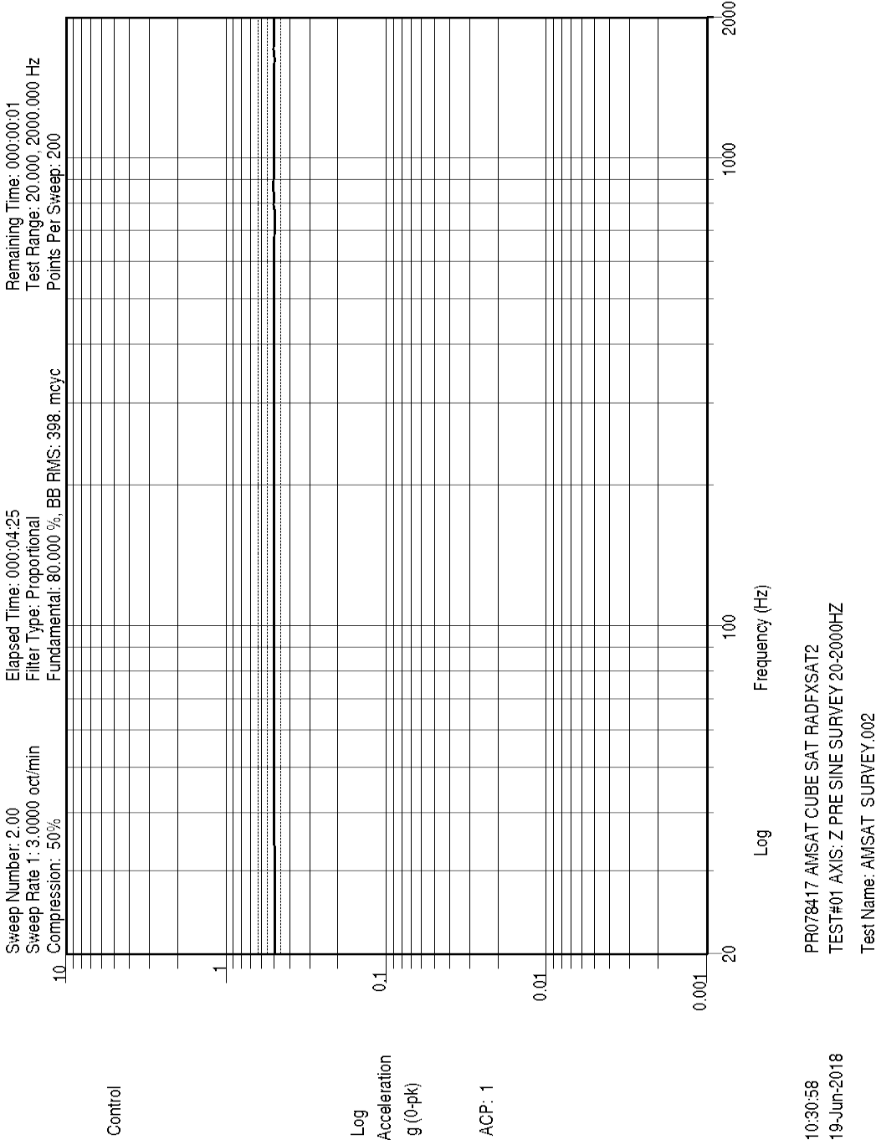

Figure 6 Z-axis pre-random sine sweep, Control

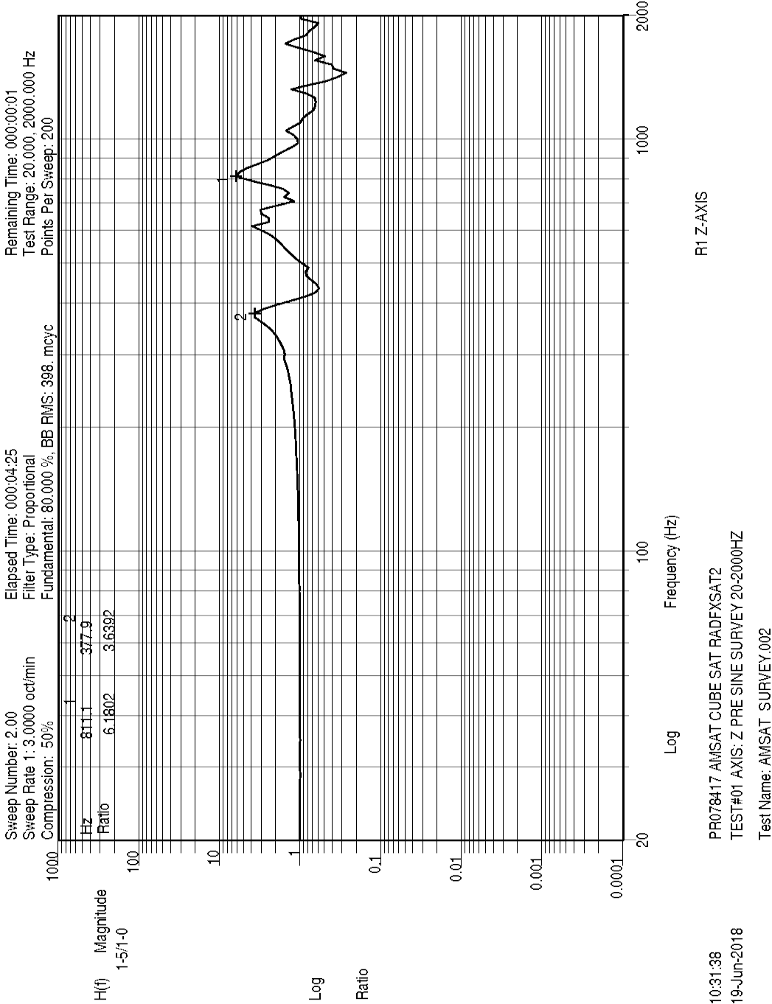

Figure 7 Z-axis pre-random sine sweep, Z Response

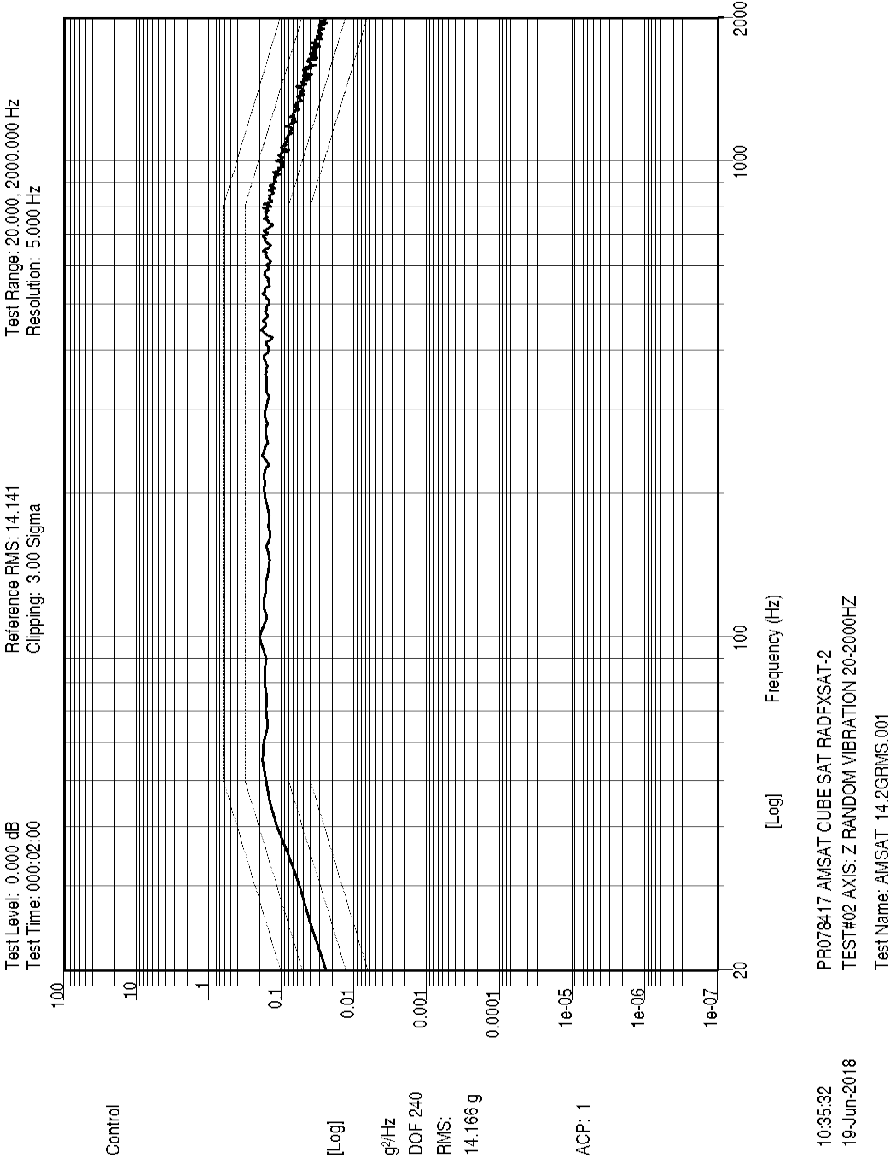

Figure 8 Z-axis random, Control

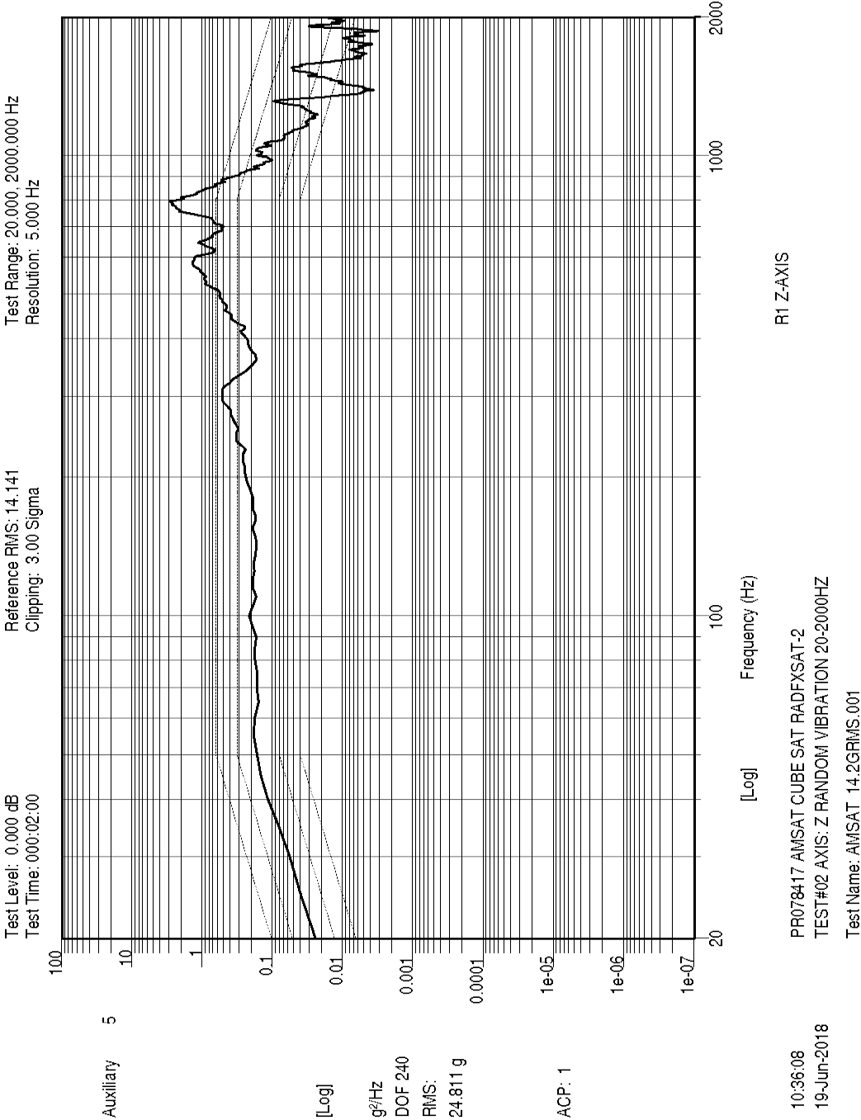

Figure 9 Z-axis random, Z Response

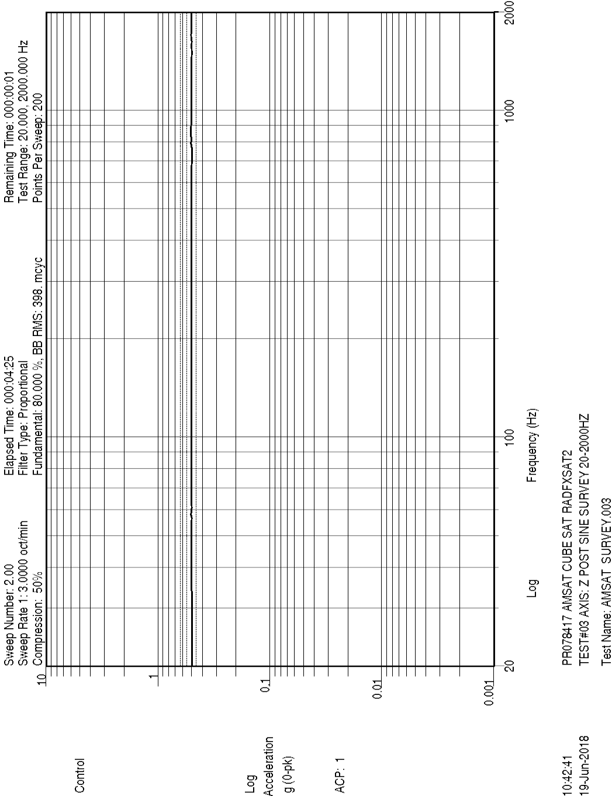

Figure 10 Z-axis post-random sine sweep, Control

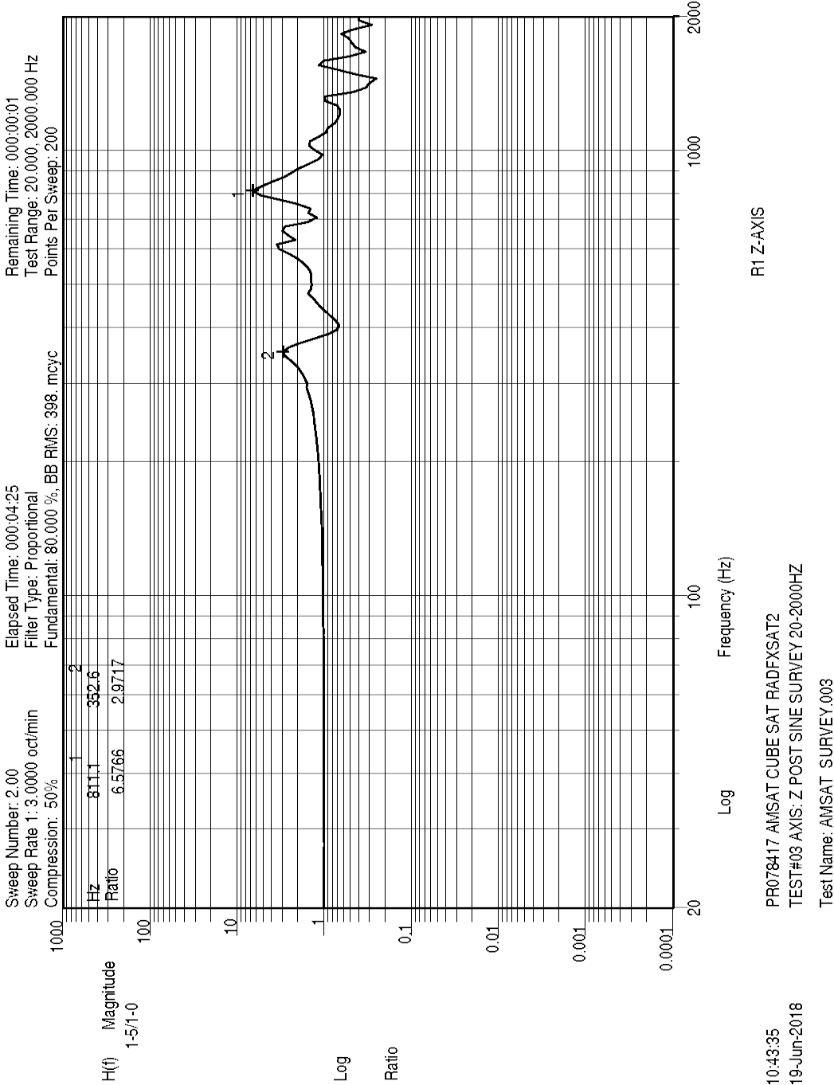

Figure 11 Z-axis post-random sine sweep, Z response

The first two modes were compared, pre- and post- sine surveys, in frequency and amplitude ratio. These modes are not thought to represent actual modes of RadFxSat-2 circuit boards (solar panels or internal boards). Far more likely these are fixture modes. A corner of the TestPOD was used as response. It is probably not meaningful to apply NASA-HDBK-7008 §5.4.1.1 to assume a shift in the CubeSat load path if primary/secondary mass modes change by greater than 5%/10% respectively.

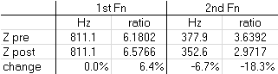

Table 2 Z-axis first modes comparison pre/post

* + **X-axis Data**

X-axis was performed by simply rotating on the slip table, and using Procedure Rev 3.

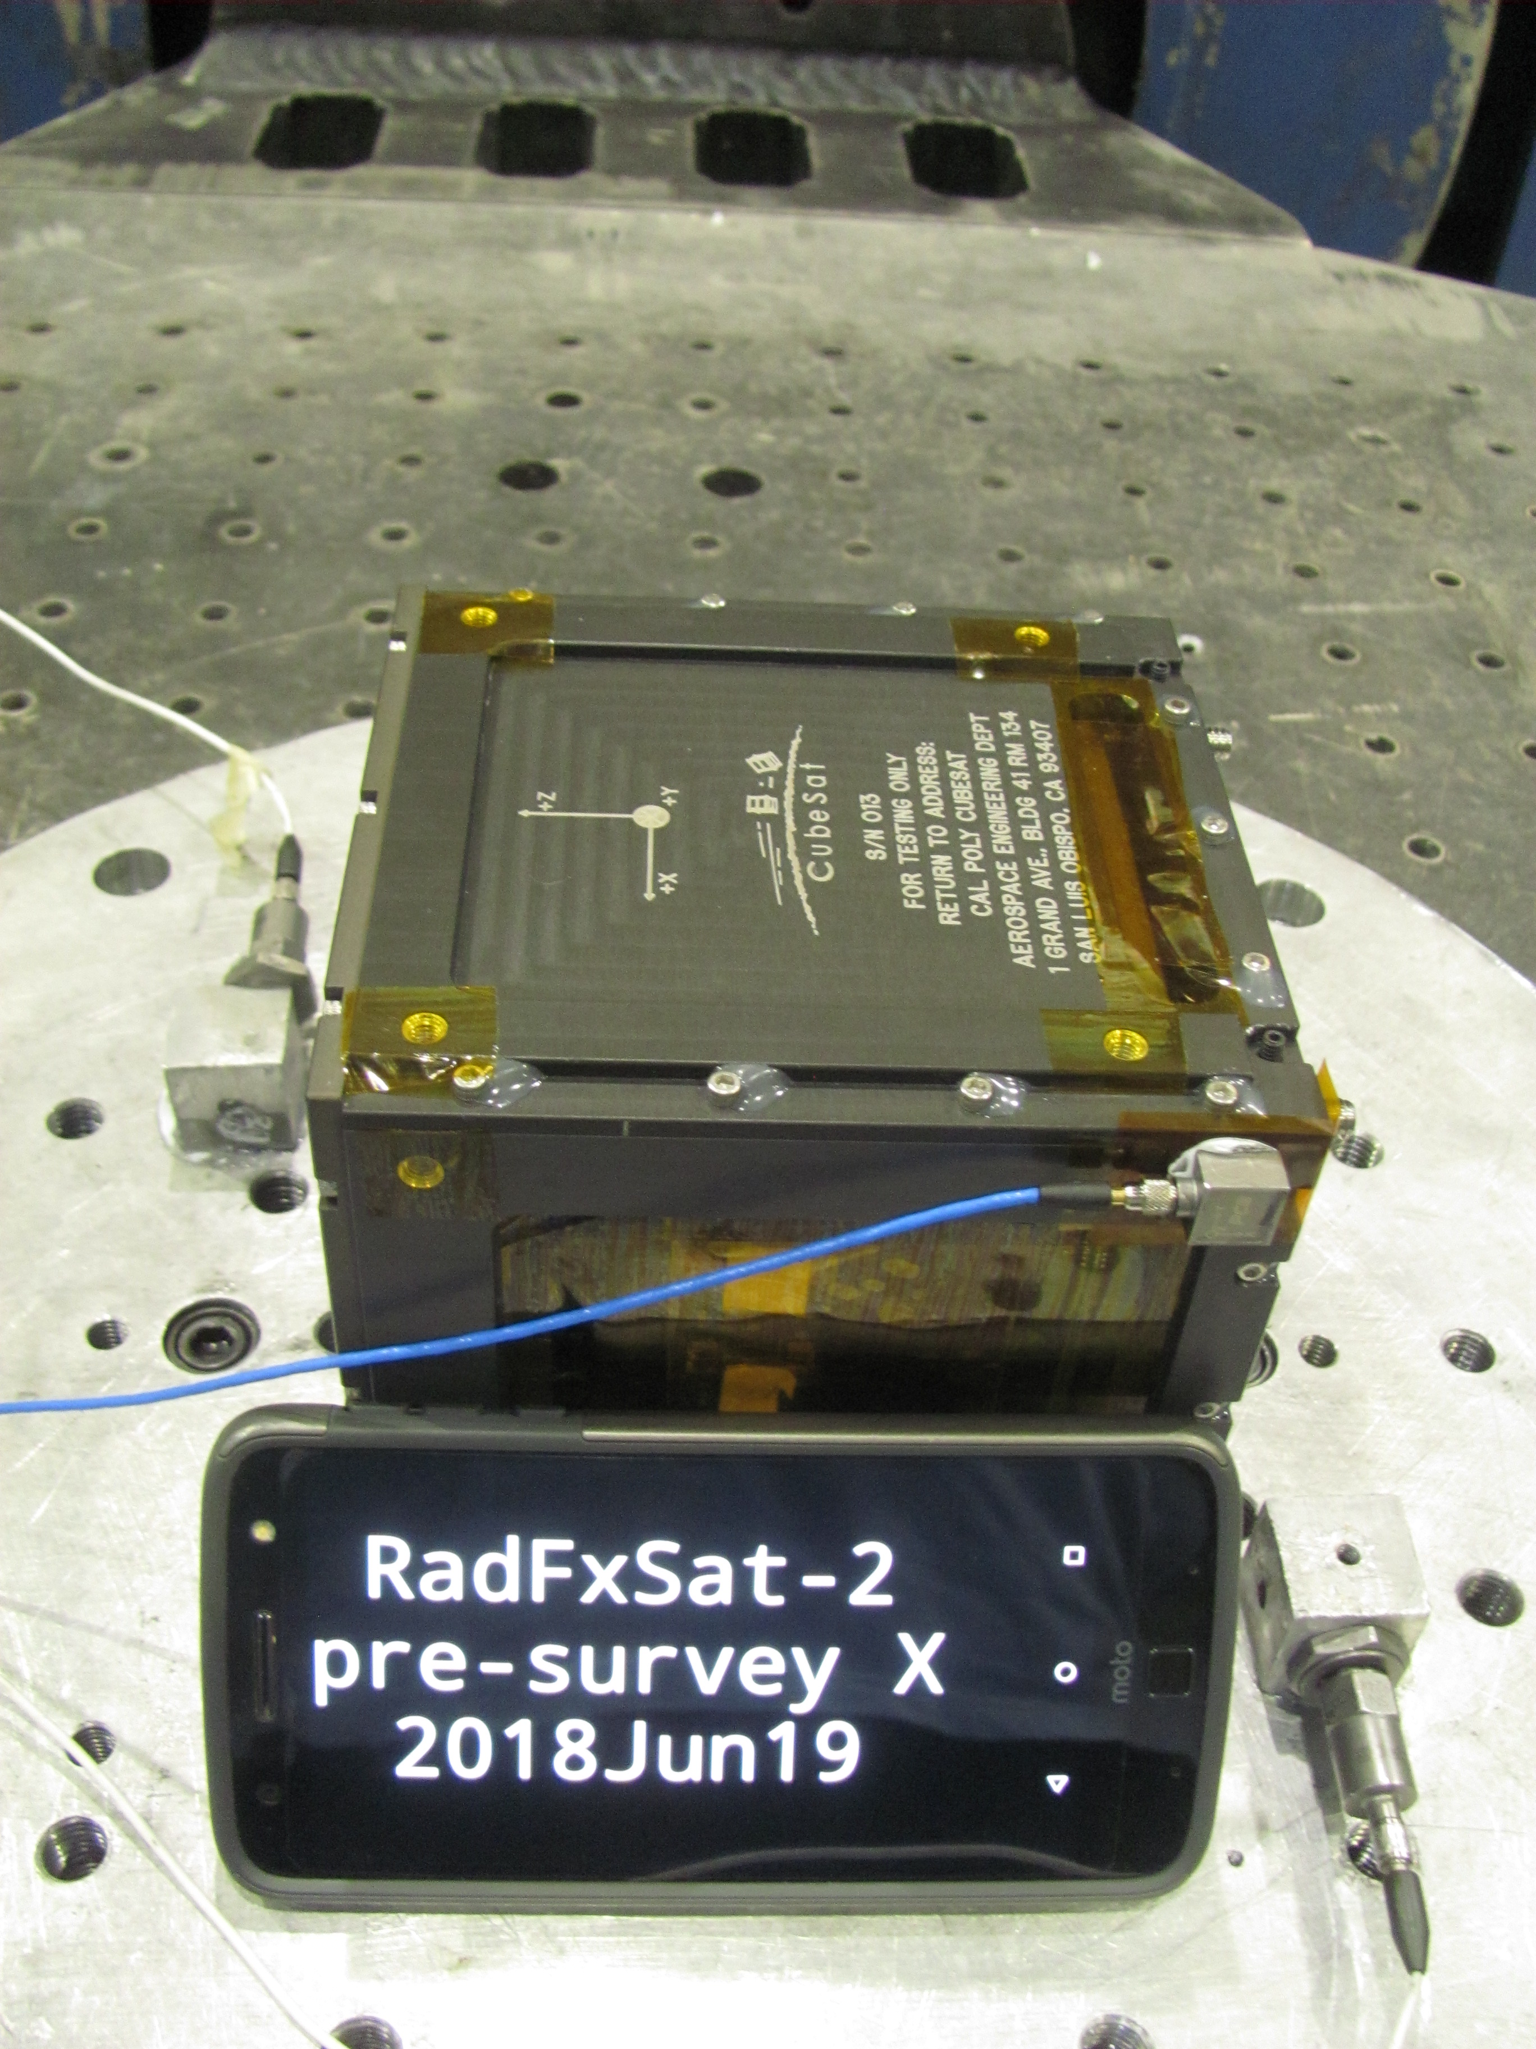

Figure 12 X-axis test setup

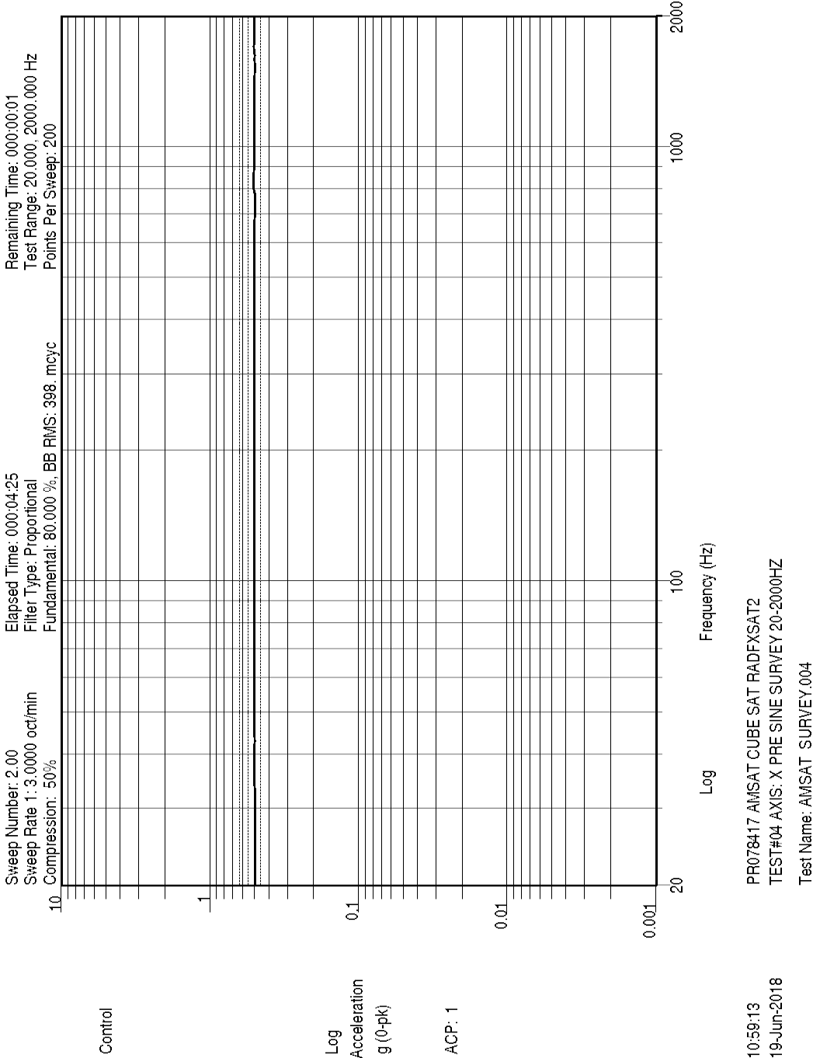

Figure 13 X-axis pre-random sine sweep, Control

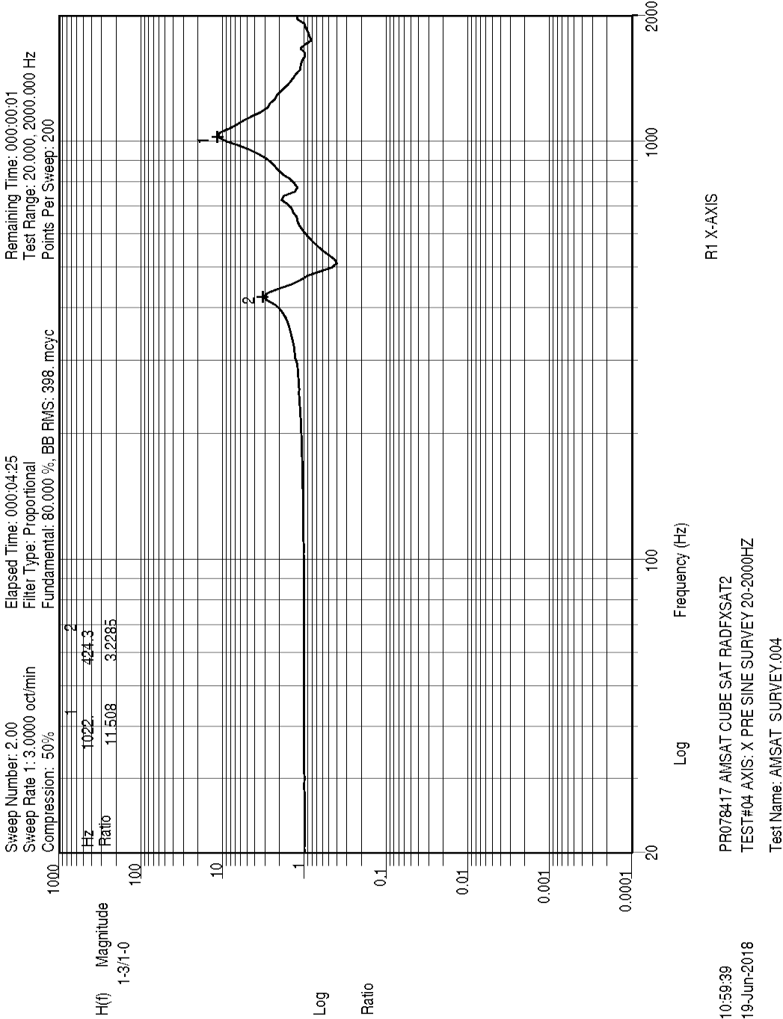

Figure 14 X-axis pre-random sine sweep, X response

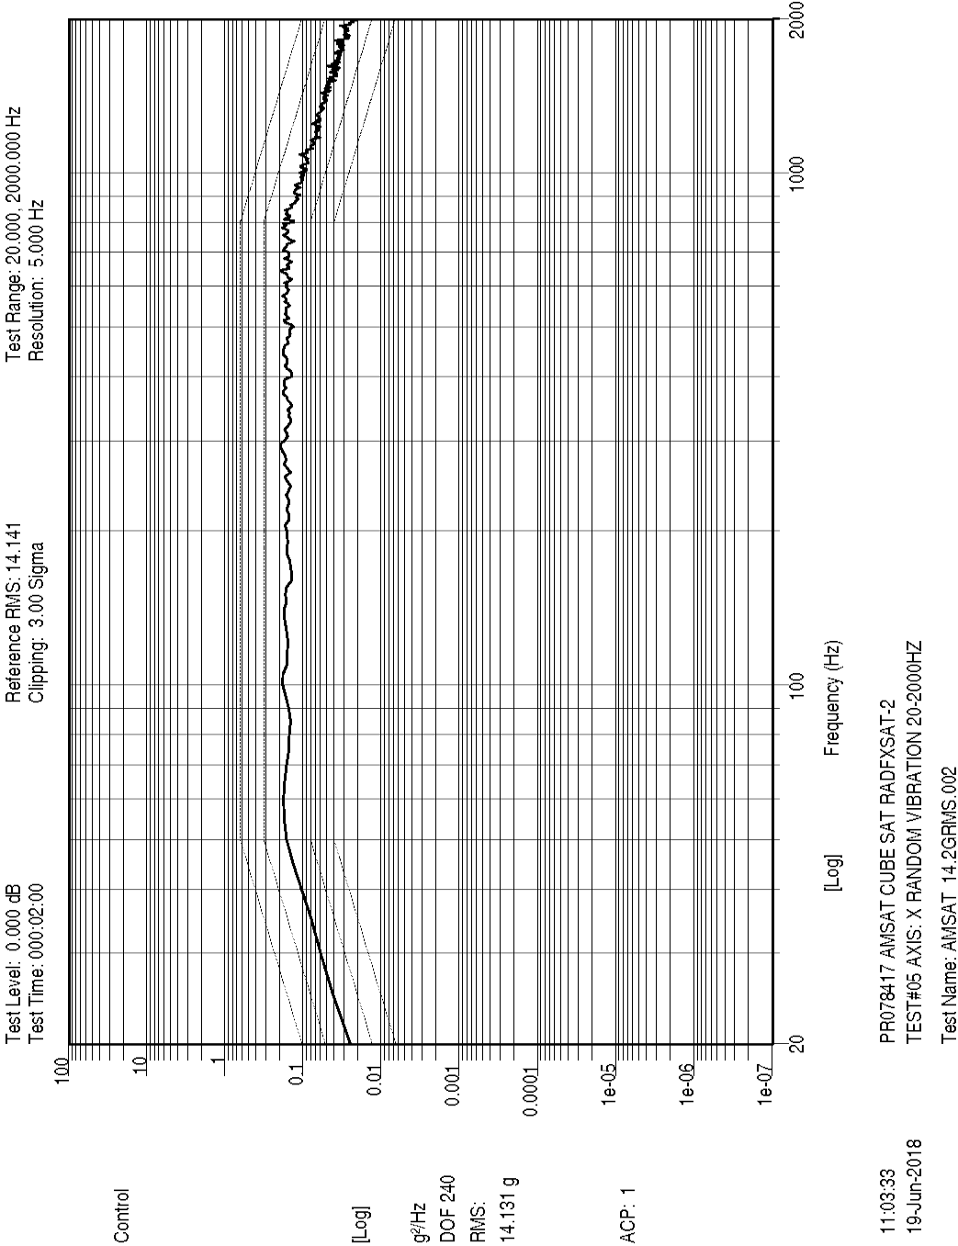

Figure 15 X-axis random, Control

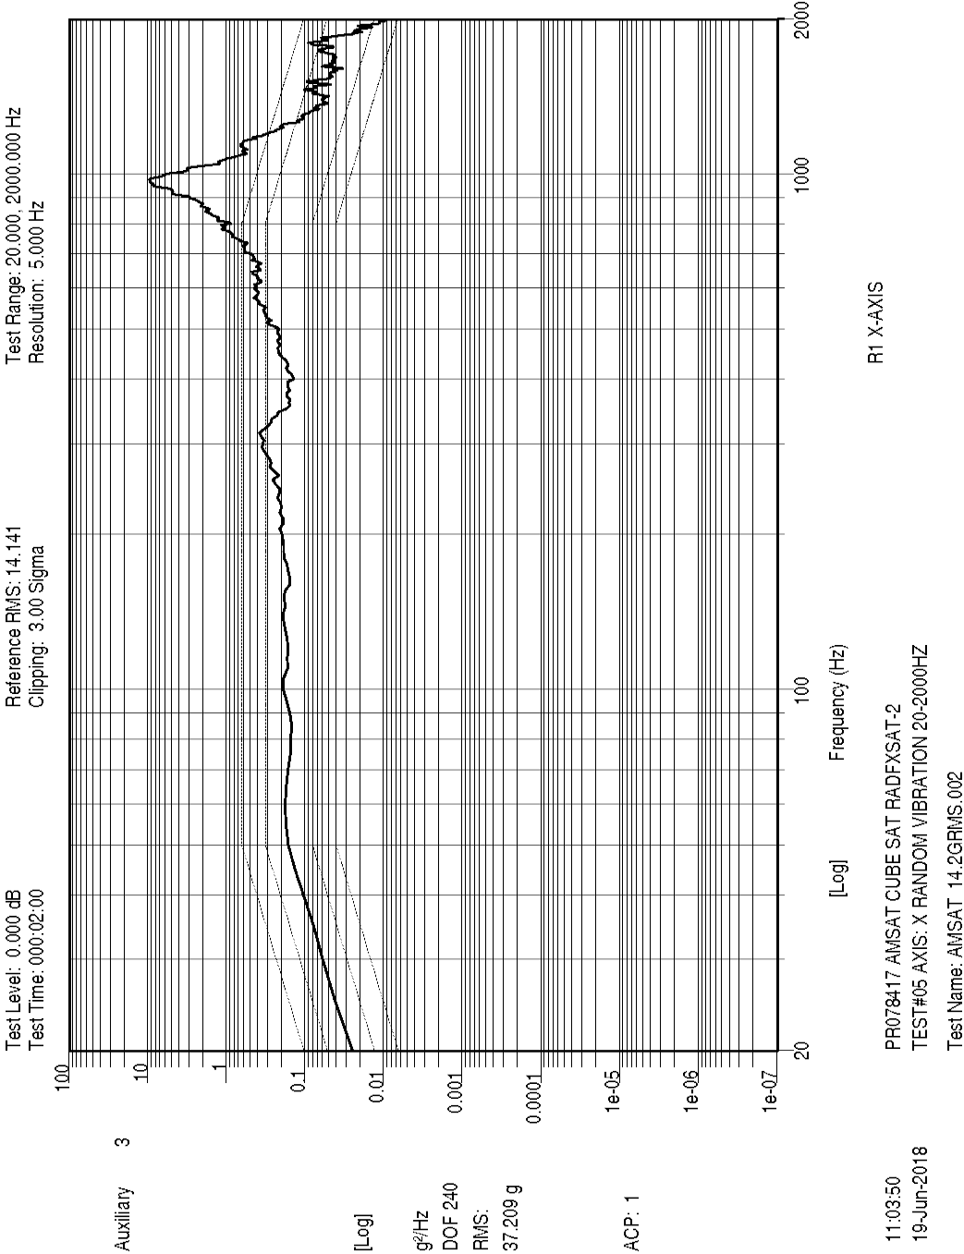

Figure 16 X-axis random, X response

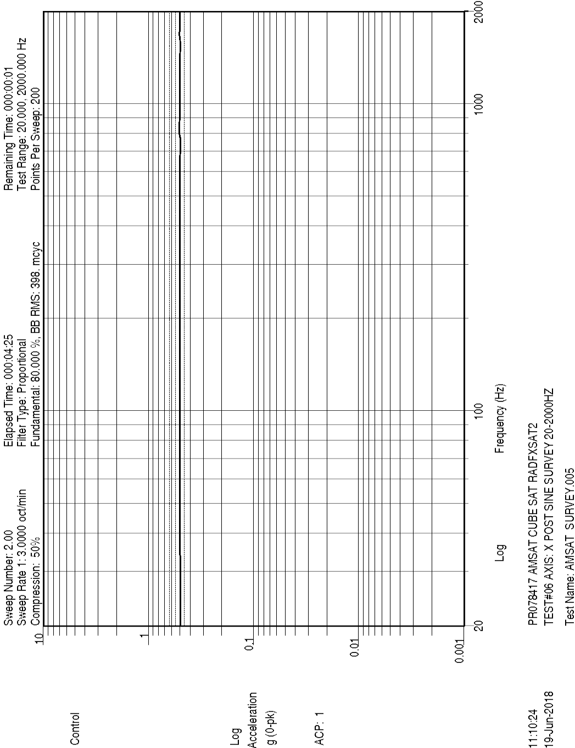

Figure 17 X-axis post-random sine sweep, Control

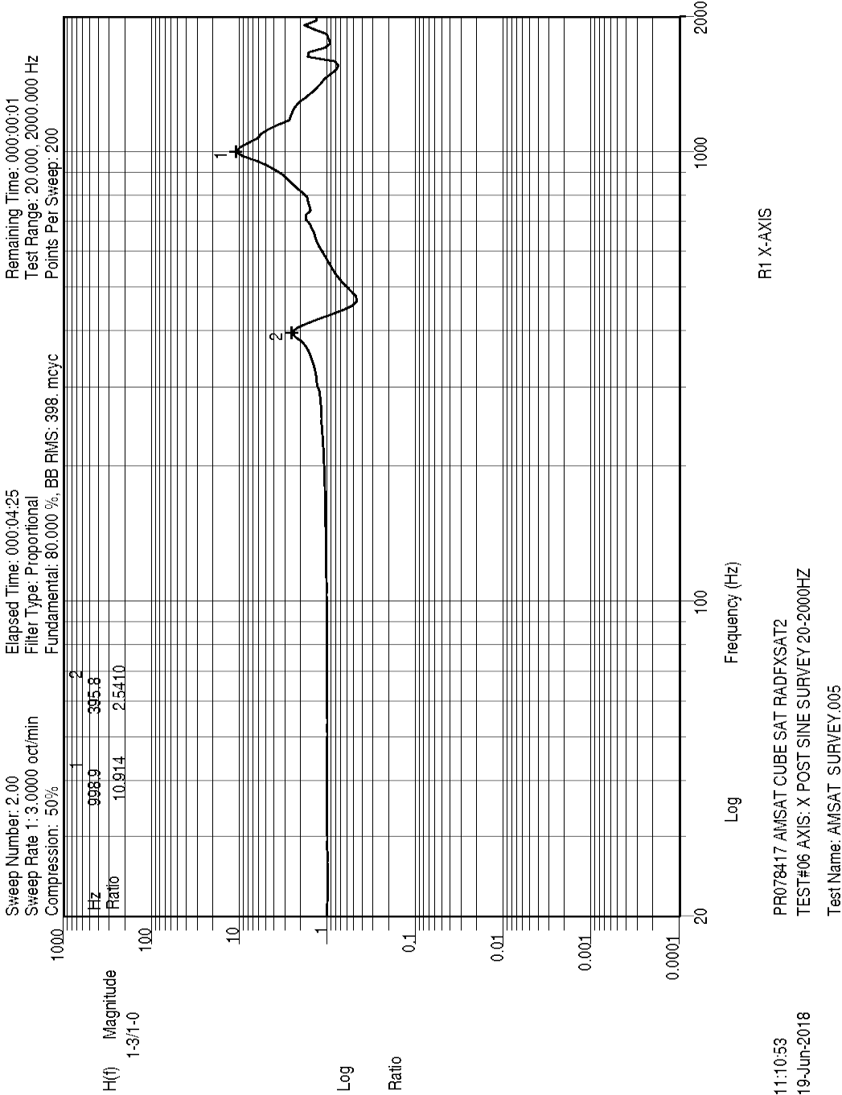

Figure 18 X-axis post-random sine sweep, X response

The first two modes were compared, pre- and post- sine surveys, in frequency and amplitude ratio. These modes are not thought to represent actual modes of RadFxSat-2 circuit boards (solar panels or internal boards). Far more likely these are fixture modes. A corner of the TestPOD was used as response. It is probably not meaningful to apply NASA-HDBK-7008 §5.4.1.1 to assume a shift in the CubeSat load path if primary/secondary mass modes change by greater than 5%/10% respectively.

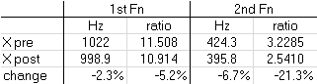

Table 3 X-axis first modes comparison pre/post

* + **Y-Axis Data**

Y-axis was performed after the Exciter was rotated, and using Procedure Rev 3.

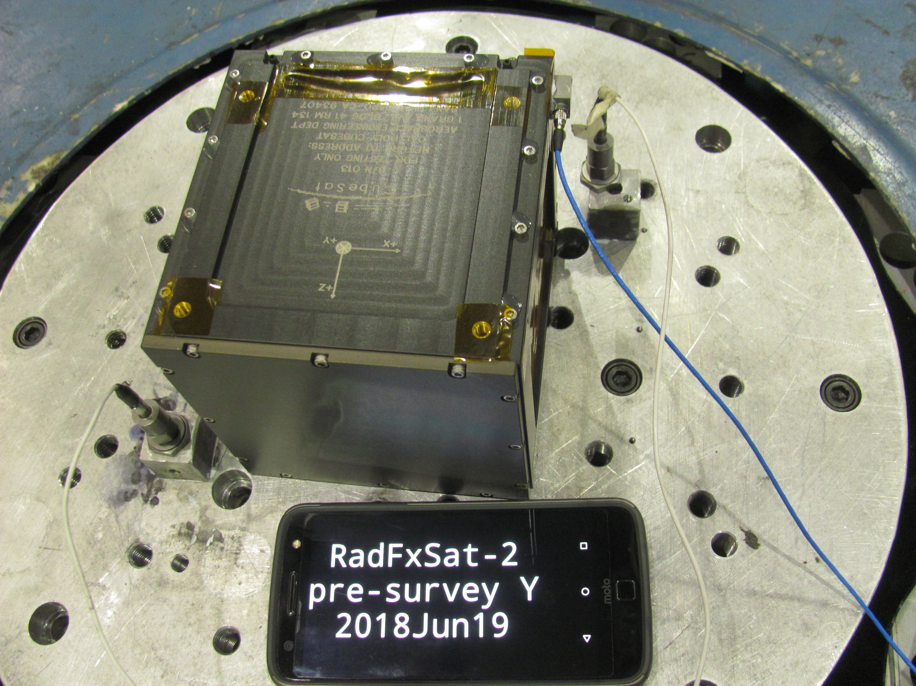

Figure 19 Y-axis setup

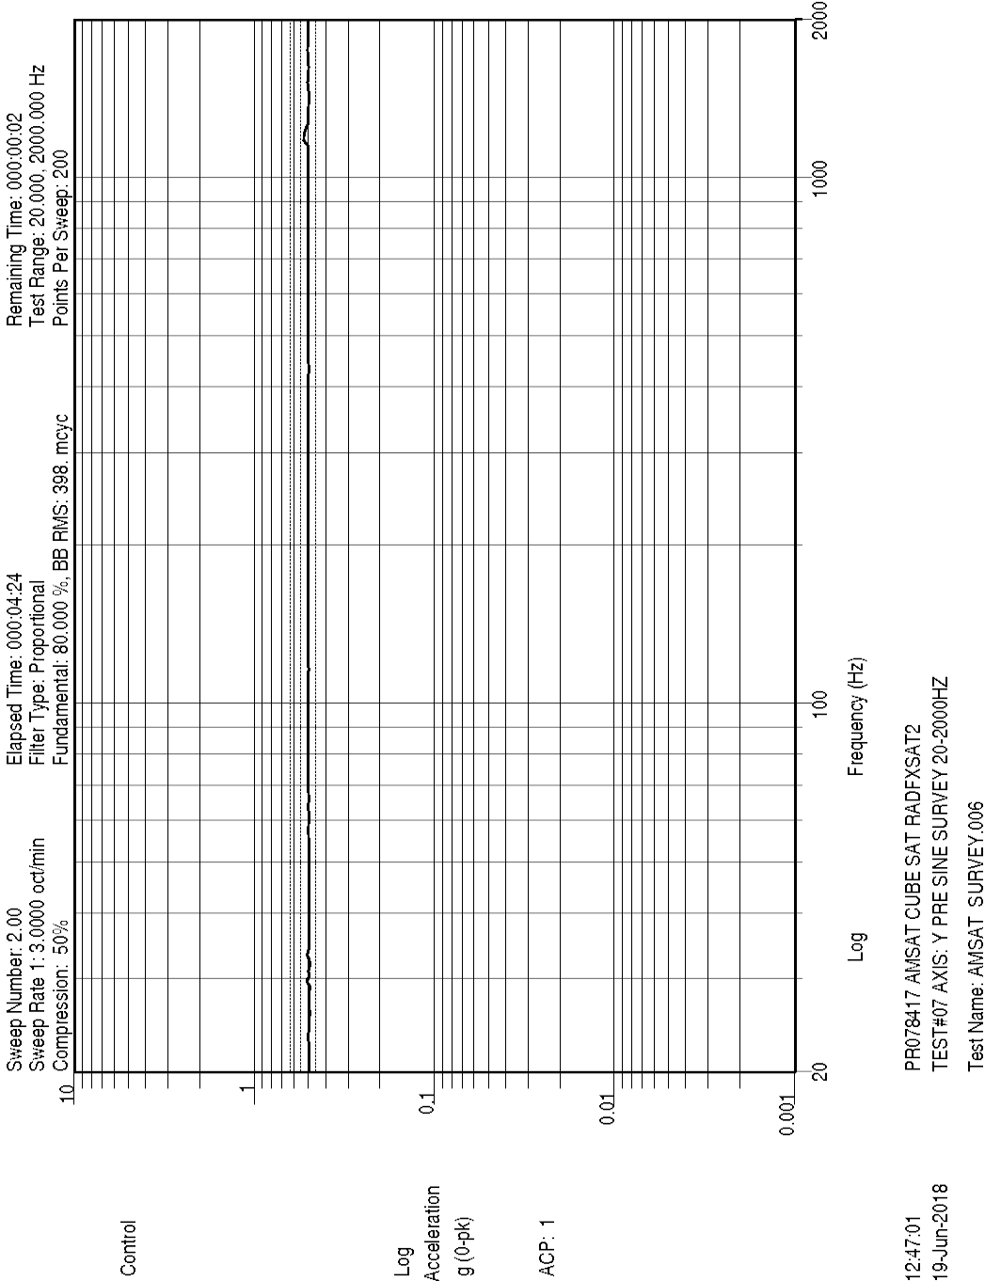

Figure 20 Y-axis pre-random sine sweep, Control

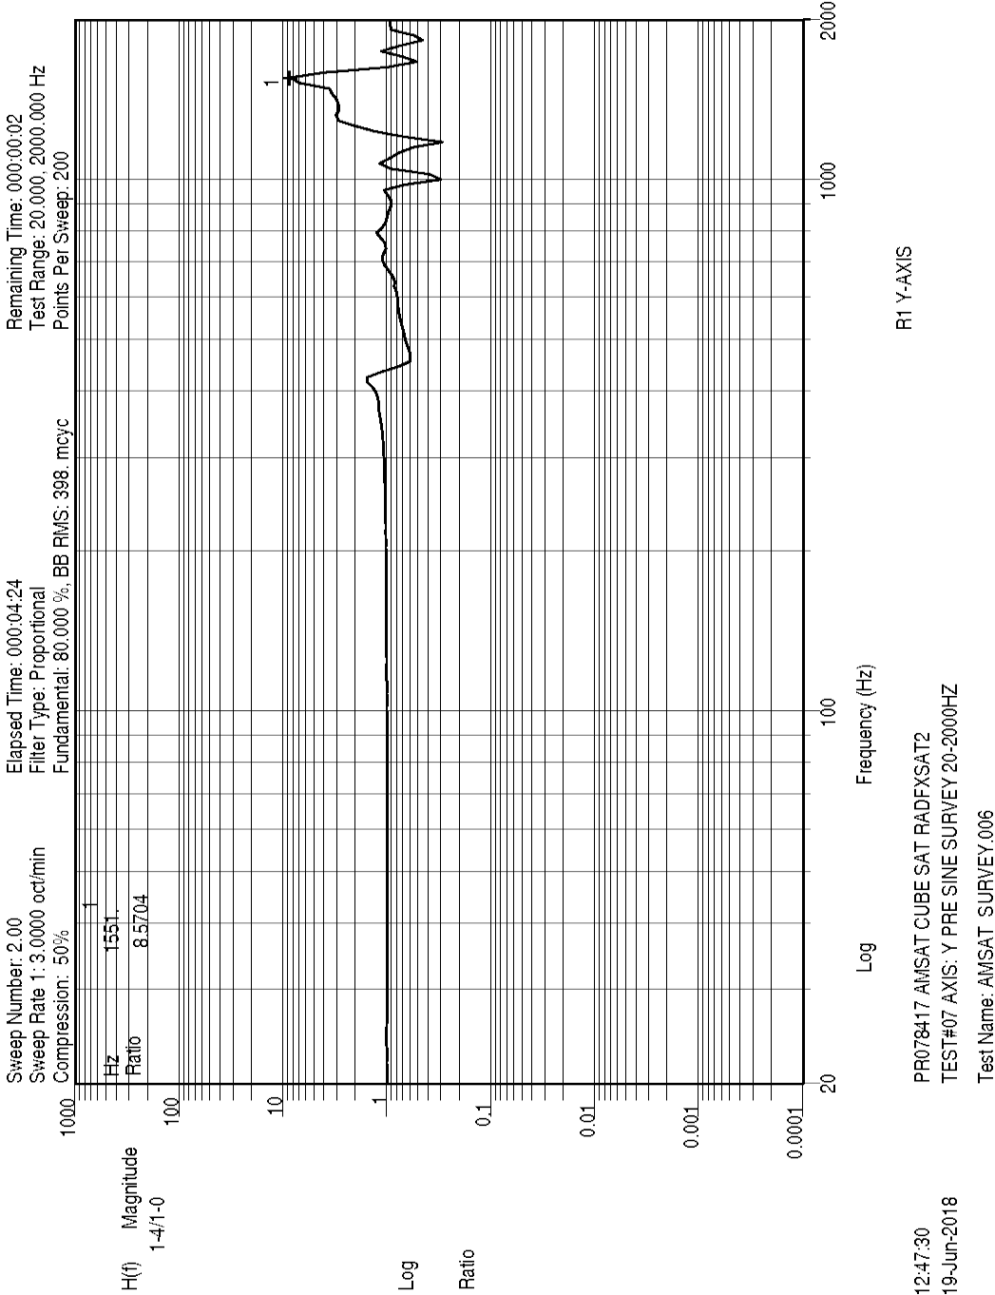

Figure 21 Y-axis pre-random sine sweep, Y response

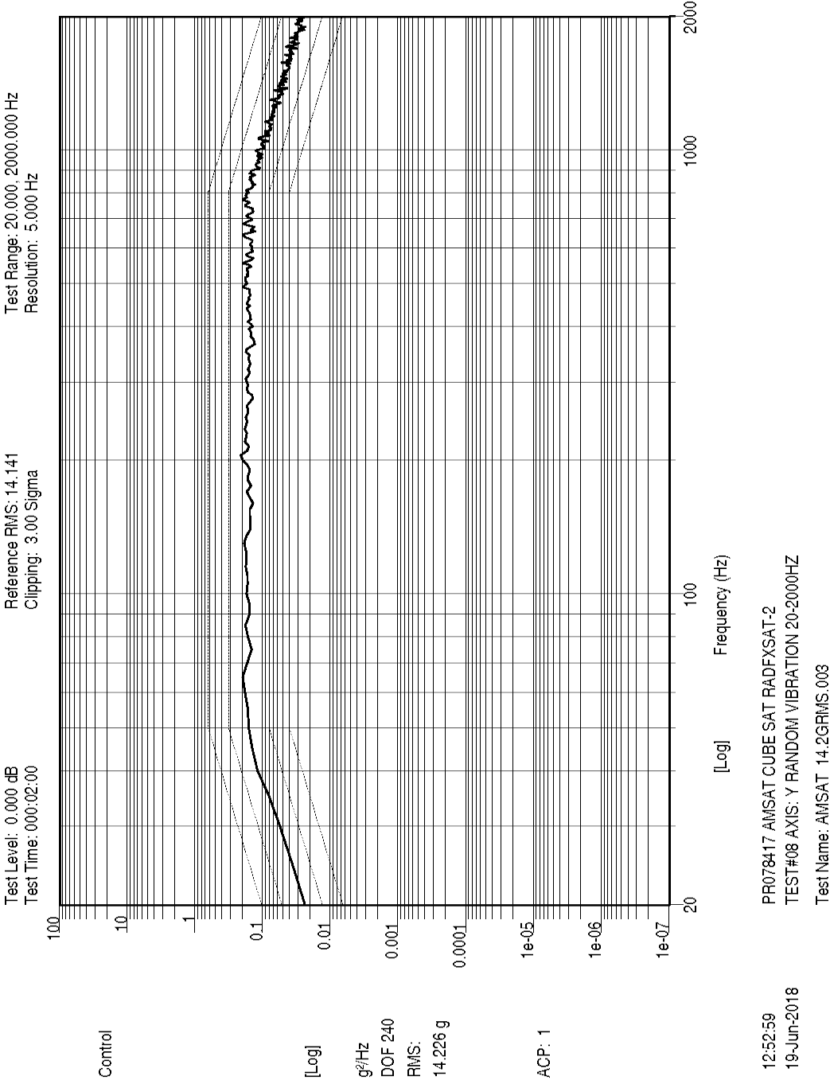

Figure 22 Y-axis random, Control

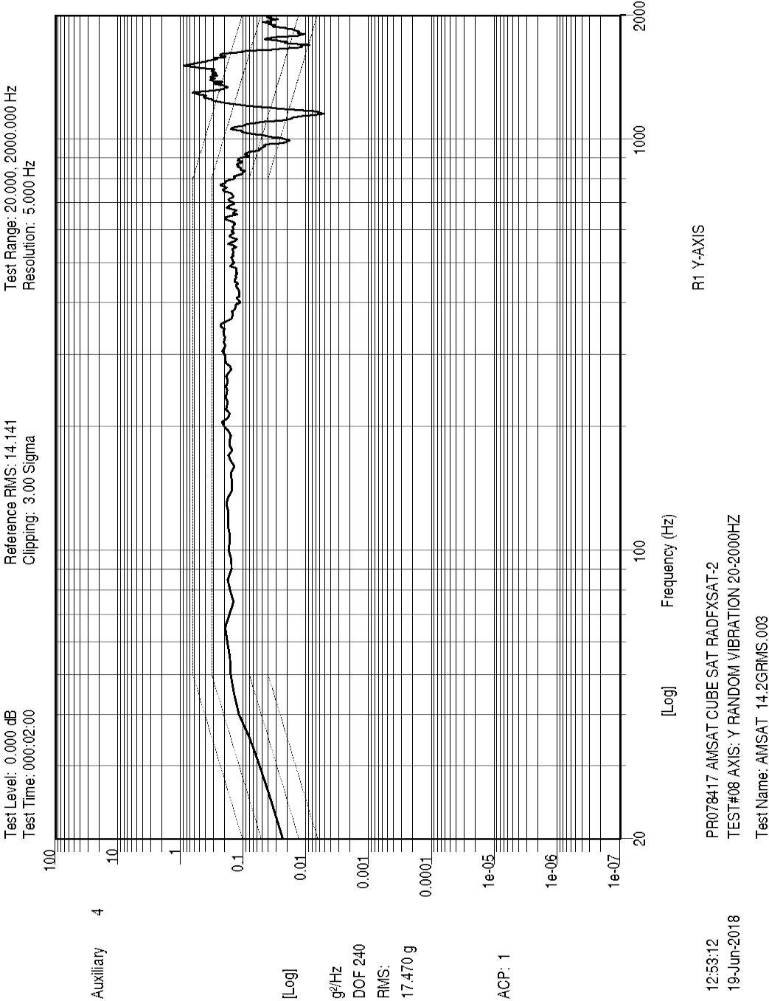

Figure 23 Y-axis random, Y response

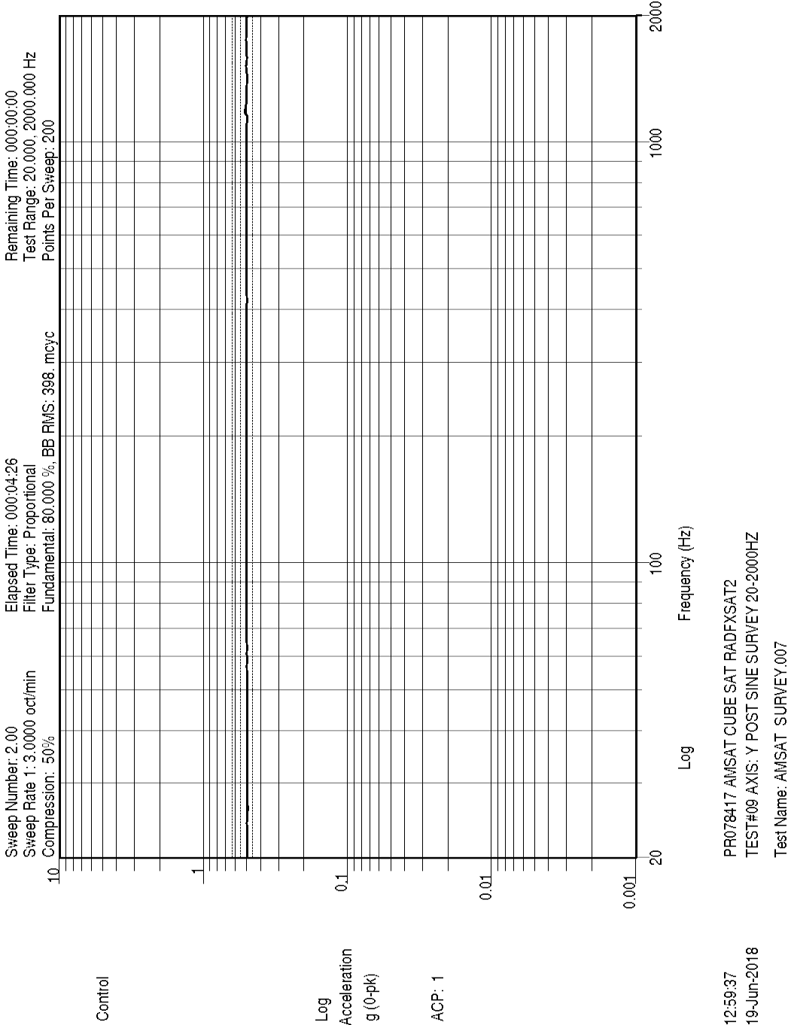

Figure 24 Y-axis post-random sine sweep, Control

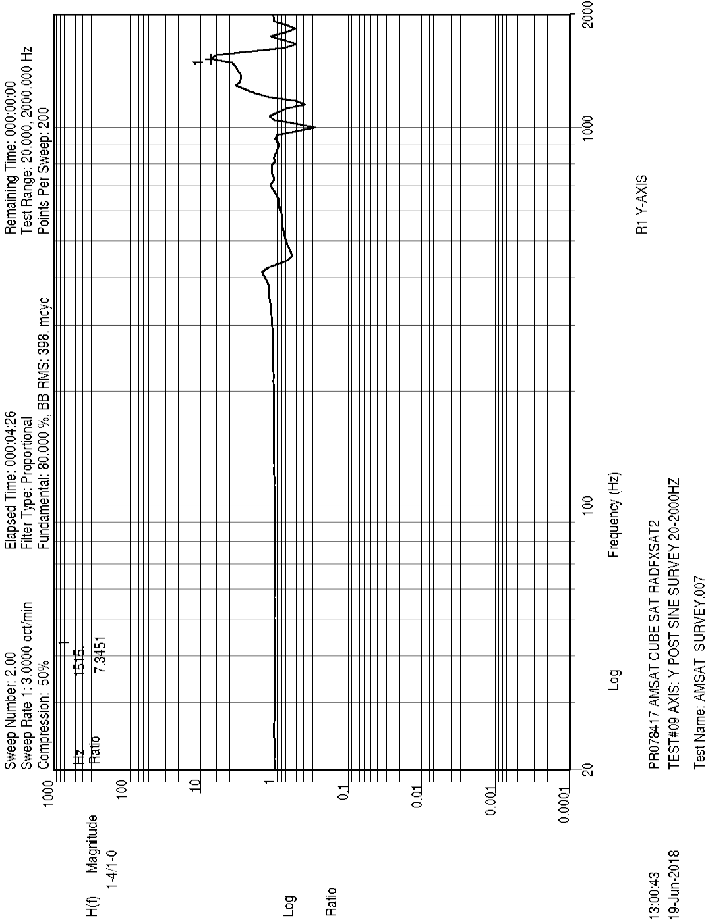

Figure 25 Y-axis post-random sine sweep, Y response

The first mode was compared, pre- and post- sine surveys, in frequency and amplitude ratio. This mode is not thought to represent actual modes of RadFxSat-2 circuit boards (solar panels or internal boards). Far more likely this is a fixture mode. A corner of the TestPOD was used as response. It is probably not meaningful to apply NASA-HDBK-7008 §5.4.1.1 to assume a shift in the CubeSat load path if primary mass mode change by greater than 5%.

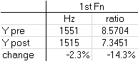

Table 4 Y-axis first mode comparison pre/post

* + **Post Vibration Inspection**

RadFxSat-2 was monitored after each vibration run for unintentional turn-on indicated by either flashing LED, audible beep, or RF transmission. No indications of unintentional turn-on were observed.

RadFxSat-2 was inspected after de-integration from TestPOD. No wear on the four +Z Rail Ends and their contact areas on the door of the TestPOD was noted. No additional wear of the 4 rails and their contact areas inside the TestPOD was noted. No wear of the –Z Rails Ends and their contact areas on the pusher plate of the TestPOD was noted.

No RadFxSat-2 visual anomalies were observed.

No TestPOD visual anomalies were observed.

The Xtenti CubeSat Accceptance Checklist was successfully completed again, and again there were no envelope exceedances. Photos of the stowed positions of the tips of both antennas were compared, and no visible difference was observed.

* + **Post Vibration Operational Tests**

After de-integration from the TestPOD, RadFxSat-2 was operationally tested again.

RadFxSat-2 passed the Short Functional Test (umbilical power; battery charge; umbilical & RF commands; RF transmitted telemetry including antennas are stowed; RF transmitted automated voice announcement; RF voice repeater operation), with the notable anomaly that the REM experiment board did not produce valid data.

The instance counter indicated that RadFxSat-2 had not accidentally turned-on during vibration testing while inside the TestPOD.

RadFxSat-2 passed the Aliveness Test (pull RBF pin then hear buzzer; re-install RBF pin before antennas deploy).

**Summary**

On June 19, 2018, RadFxSat-2 completed Prototype Qualification random vibration profile (14.12Grms, 2 minutes/axis, 3 axes). After completion of the vibration, inspections and functional tests were completed successfully, with the noted anomaly of REM experiment board not providing valid data during Short Functional Test.

.

**Compliance Certification:**

I certify that RadFxSat-2 is in compliance with ELaNa XX requirement L1-VCLS-ICD-20 (ICD ¶3.6.5.1) (random vibration).

Sincerely,



Gerald Buxton

Vice President - Engineering

AMSAT

(817) 573-2465